

Computer Science A Level | AQA | 7517

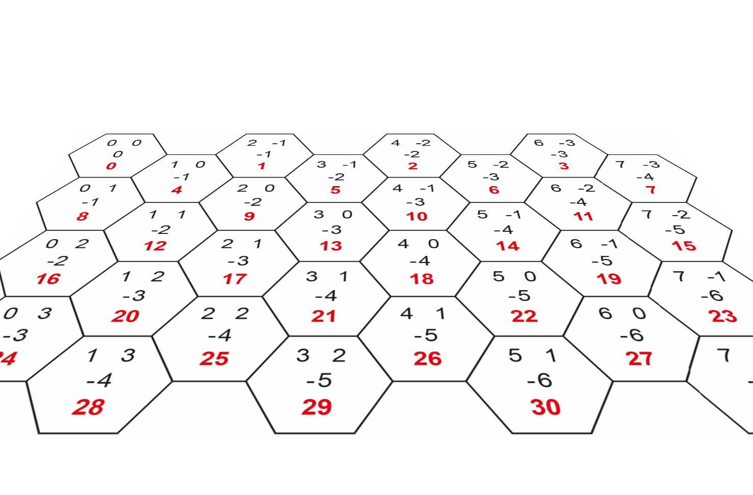

PAPER 1 EXAM RESOURCE PACK 2021

HEX BARON

for A Level AQA Computer Science

PYTHON3 EDITION

2015 specification

for the 2021 exam

Photocopiable/digital resources may only be copied by the purchasing institution on a single site and for their own use

DE9/

10586

Publish your

own work...

Write to a brief...

Register at

publishmenow.co.uk

POD

10586

zigzageducation.co.uk

Contents

Product Support from ZigZag Education ii

Terms and Conditions of Use iii

Teacher's Introduction iv

**Printouts of CD resources (for reference)**

▪ Commentary (12 pages)

▪ Class Diagram Tasks (3 pages)

▪ Theory Questions: Write-on version (5 pages)

▪ Theory Questions: Non-write-on version (3 page)

▪ Programming Tasks (17 pages)

▪ Additional Tasks (Extension) (1 page)

▪ Class Diagram Tasks: Solutions (3 pages)

▪ Class Diagram Full (1 pages)

▪ Theory Questions: Mark Scheme (3 pages)

▪ Programming Tasks: Mark Scheme (44 pages)

▪ Electronic Answer Document (3 pages)

Product Support from ZigZag Education

🡲 Computer Science & IT 🡲 Product Support

[ZigZagEducation.co.uk](http://zigzageducation.co.uk)

Quick link: [zzed.uk/PS](https://zzed.uk/PS)



Product Support



Get Product Updates

Occasionally we make improvements to resources after you receive them.

Download the updated content **free of charge**.

Download Support Files

Any support files for your purchased resources are available for download.

This includes HTML links pages for resources that contain lots of hyperlinks.

Send us Your Feedback

For every completed review, **get a £10 voucher** to use on your next order!

Tell us what you thought, and report any issues or ideas for improvement.

Get New Resource Notifications

Opt in to receive email alerts about new resources for your subject(s).



Contact Us

[zigzageducation.co.uk](http://zigzageducation.co.uk)

[sales@zigzageducation.co.uk](mailto:sales@zigzageducation.co.uk)

0117 950 3199

ZigZag Education

Unit 3 Greenway Centre  
Doncaster Road   
Bristol BS10 5PY



Register today via:

*Ever considered publishing your work?*

*Join PublishMeNow, our  
teacher-author website, today!*

Terms and Conditions of Use

**Terms and Conditions**

Please note that the **Terms and Conditions** of this resource include point 5.3, which states:

|  |
| --- |
| **“You acknowledge that you rely on your own skill and judgement in determining the suitability of the Goods for any particular purpose.”** |

“We do not warrant: that any of the Goods are suitable for any particular purpose (e.g. any particular qualification), or the results that may be obtained from the use of any publication, or expected exam grades, or that we are affiliated with any educational institution, or that any publication is authorised by, associated with, sponsored by or endorsed by any educational institution.”

**Copyright Information**

Every effort is made to ensure that the information provided in this publication is accurate and up to date but no legal responsibility is accepted for any errors, omissions or misleading statements. It is ZigZag Education’s policy to obtain permission for any copyright material in their publications. The publishers will be glad to make suitable arrangements with any copyright holders whom it has not been possible to contact.

Students and teachers may not use any material or content contained herein and incorporate it into a body of work without referencing/acknowledging the source of the material (“Plagiarism”).

**Disclaimer**

This resource is intended to supplement your teaching only.

It is the teacher’s responsibility to decide how to use this resource to assist themselves and their students appropriately. You may simply wish to read this material to better inform yourself and to help you prepare your lessons and to give you ideas for your teaching. You may also consider whether it is appropriate to hand out some of the sheets for reference and to use some of the activities for classwork or homework. You may also consider whether it is appropriate to hand out the booklet to be worked through by your students more independently.

As with all pre-release material, it is the teacher’s responsibility to decide in what way to assist their students, and to decide how this resource in particular can be used to fit into that assistance.

The resources here are provided as an interpretation of the pre-release material.

The author does not have any special knowledge of what to expect on any particular exam.

ZigZag Education is not affiliated with AQA, Pearson, Edexcel, OCR, WJEC, CEA, International Baccalaureate Organization or DFE in any way nor is this publication authorised by, associated with, sponsored by or endorsed by these institutions unless explicitly stated on the front cover of this publication.

This publication is designed to supplement teaching only. Practice questions may be designed to follow the content of a specification and may also attempt to prepare students for the type of questions they will meet in the examination, but will not attempt to predict future examination questions. ZigZag Education do not make any warranty as to the results that may be obtained from the use of this publication, or as to the accuracy, reliability or content of the publication.

Where the teacher uses any of the material from this resource to support examinations or similar then the teacher must ensure that they are happy with the level of information and support provided pertaining to their personal point of view and to the constraints of the specification and to others involved in the delivery of the course. It is considered essential that the teacher adapt, extend and/or censor any parts of the contained material to suit their needs, the needs of the specification and the needs of the individual or group concerned. As such, the teacher must determine which parts of the material, if any, to provide to the students and which parts to use as background information for themselves. Likewise, the teacher must determine what additional material is required to cover all points on the specification and to cover each specification point to the correct depth.

# Teacher's Introduction

This resource pack is designed to help you support your students taking the A Level Computer Science Paper 1 exam. It is based on the *Hex Baron* preliminary material (Python3) – for examination summer 2021.

On the CD, you will find the following:

🗀 HexBaron this folder contains all of the content (PDF/DOCX) accessible via a HTML interface

🗏 Passwords.txt for teacher use – this file contains all of the passwords for the protected PDFs (also listed below)

* PRINTED COPIES OF ALL THE MATERIALS IN THIS DIGITAL RESOURCE PACK ARE INCLUDED FOR REFERENCE.

Installation: Copy the entire HexBaron folder onto a network location that is accessible for students, and provide them with a shortcut to the index.html file. All content can be accessed from this page.

Passwords: All of the PDFs accessible via the *Solutions* web page are password-protected, so that students can only access them with your permission. Each password is a four-digit code, as follows:

🗏 p06a-ClassDiagramTasksMS.pdf 3091

🗏 p06b-ClassDiagramFull.pdf 5630

🗏 p07-TheoryQuestionsMS.pdf 7642

🗏 p08-ProgrammingTasksMS.pdf 2966

Should you wish to give students access to ALL protected-PDFs, the master password for all files is: zz2ghc4



The resource pack consists of the following:

① Pre-release Commentary including a general explanation of how the program works (text and video),   
plus a more detailed, technical overview* describing each subroutine class and method in turn.

*Note: although this section is intended to give extra support to teachers and students, it should in no way be seen as a substitute to a student exploring the code for themselves.

② Class Diagram Tasks

Three class diagram tasks for students to complete while getting to grips with the skeleton program.   
A mark scheme is provided via the *Solutions* web page as a password-protected PDF.

③ Written Questions

Theory questions testing students' understanding of the skeleton program, like Section C in the exam. These questions require access to the program, but no modifications need to be made to the program. Write-on (with answer lines) and non-write-on version are available format. Suggested answers are provided via the *Solutions* web page as a password-protected PDF.

④ Programming Tasks

Fifteen modification exercises put students' programming skills to the test, like Section D in the exam. Example solutions with suggested mark schemes are provided via the *Solutions* web page as a password-protected PDF. Note that these are example solutions and you must use your discretion to award marks accordingly where there are valid alternative solutions.

An Electronic Answer Document (EAD) is provided should you wish students to use it for ③ and/or ④ above.

This resource is intended to supplement your teaching only.  Please read full disclaimer (p. iii) before using it.